Animset and Visual Scripted Movement.

Overview:
- Diner Fbx Model is just TPose with Mesh
- Diner Prefab has Animator with mix of sitting and standing animations, as well as sit to stand and stand to sit
- The root for sitting animations is as captured in real life
(if it is below the seat, then it is not between the feet):
- Therefore a fix you can apply is to use the Root object that sits below the seat to store the offset from a foot Root, and make the Control Rig Reference (Character_Ctrl:Reference) have an offset to between the feet.
- Finally when you use both sets of animation in an Animator, you can select the root that is between the feet for animation settings and any adjustments.
- In our case it is always Root Transform in the Animations window, or Control Rig Reference (Character_Ctrl:Reference), the top root level, as the seat root offset in stored on the child Root object
  - “normal” motion capture animations -standing

  - Normal motion capture animations with Offset from motion capture choices.

  - Adjusted Animations for seated offset

- Previously in the module we were using the Sitting Loop Anims AnimSet - This had a root below the characters bottom, and was easy to use for sitting. You could spawn it to the root of the chair...
- If you want to create movement (sitting, standing, walking) it is best to put the root back between the characters feet, so that can be standard.
- FYI, the Annie TPose and Prefab in Tuts 8-10 uses the Clark Animset
- We will adjust the Clark animset to adjust the root between the feet for the animations that are sitting, to get them in line with all animations.
- I provide the raw Clark Animset, and also a fixed file, with Sit to Stand, Walk, and sitting animations with root between the feet
- The root that is moved is one level down from the Character_Ctrl:Reference
- Move it back to -30 in Z, and process as normal in Story mode via Control Rig and character - then export as a processed anim clip from Story
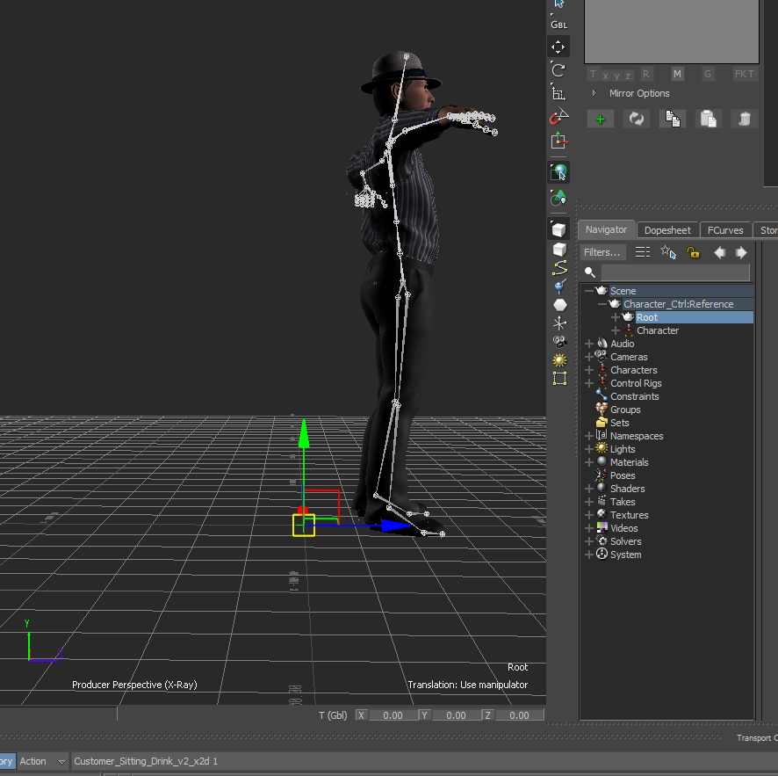
https://gyazo.com/9dd57b3df4240caeca8ff35729de9c56
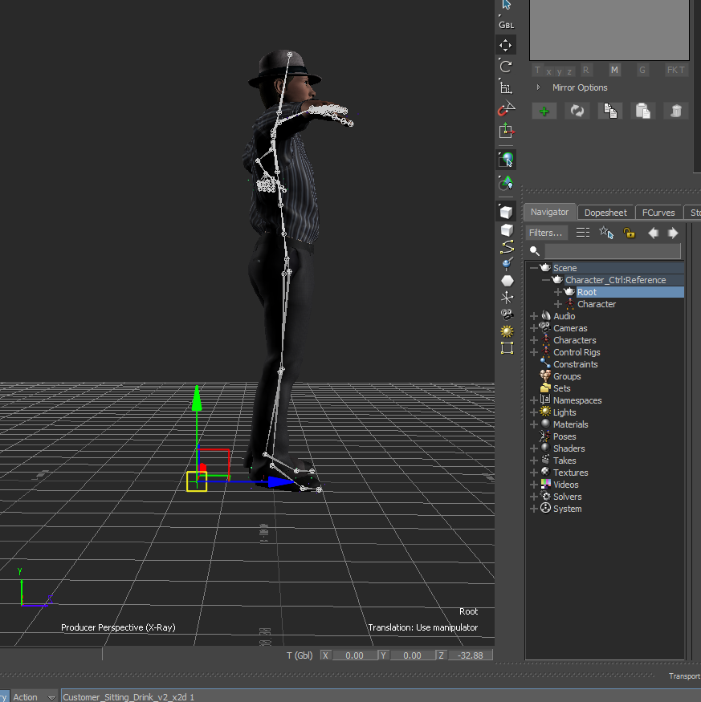
https://gyazo.com/23d5c7ee26851d93a26adc66d556bb54
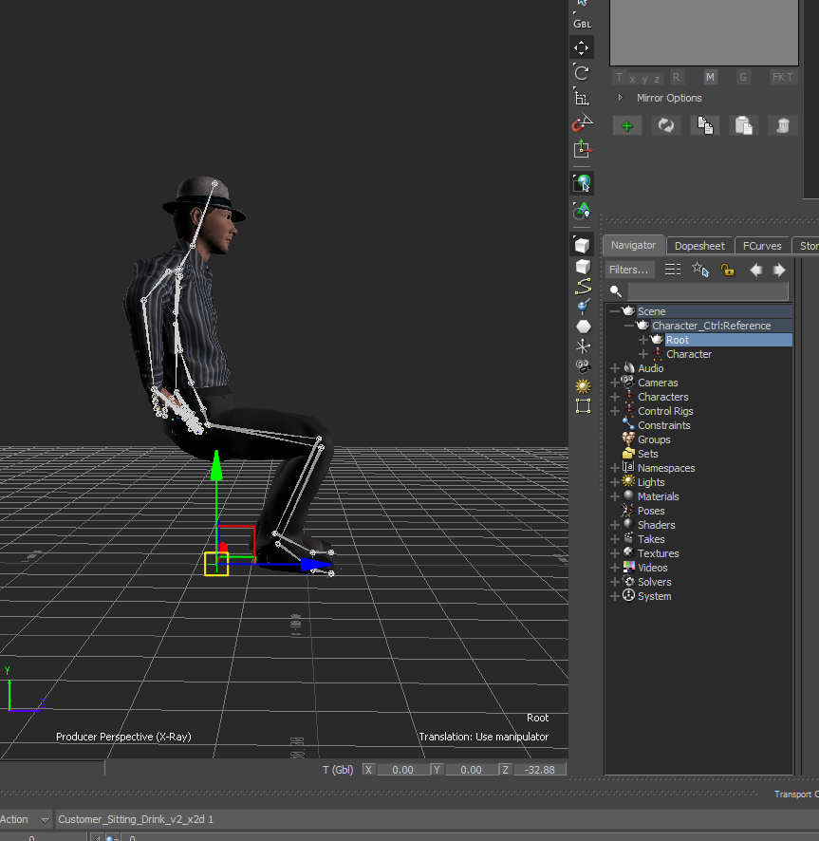
https://gyazo.com/750295854fb315295e1b42e408f3a620
- Process all required clips in this way. I have provided a basic set
- There is also a walk animation downloaded from mixamo. This can also be used when processed.
- In Unity, import all your processed clips of the new anim set and we will create a new Animator Controller with State Machine and Triggers like the one before (AC1), and plug the new animator controller into the Anne Prefab. This updates all her animation!
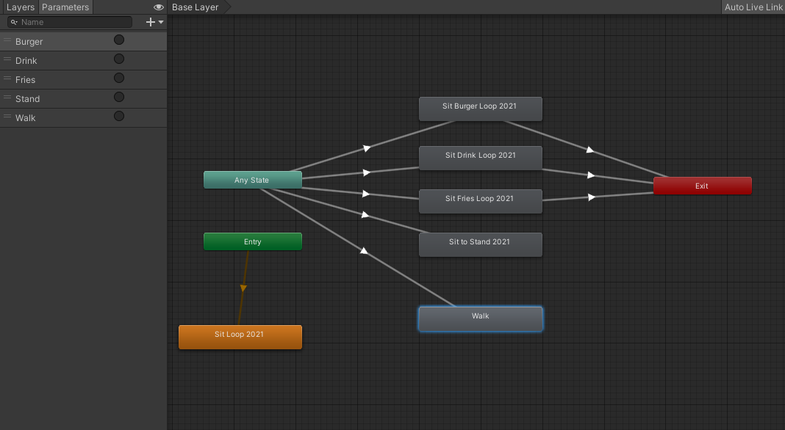
https://gyazo.com/5eb22f774e9c6c0afd7c33a1fb9e86ff
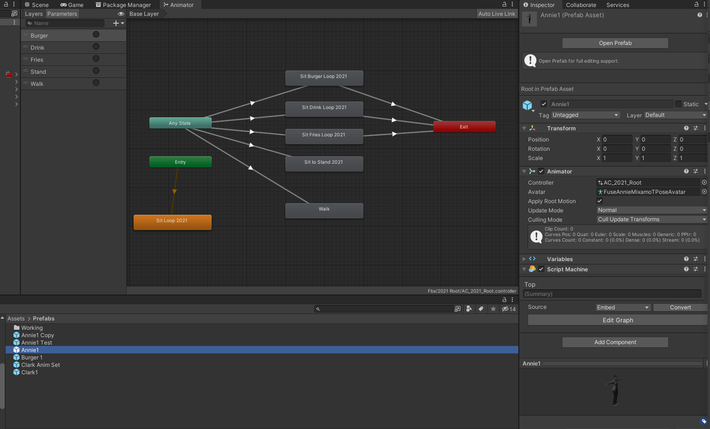
https://gyazo.com/89d564ef1a725fd482a3f3a540882508
https://gyazo.com/b85aac22fadcde8517b8d6d03a8df8c9
- Dont forget to process each animation clip for
  - Rig: Humanoid, and created from This
  - Animation: Compression off, loop for the Sit basic, and Motion Root selected as Root Transform
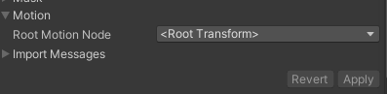

- In the Annie Prefab, script the movement as follows (on testing buttons):
- Pay Timer Adjust
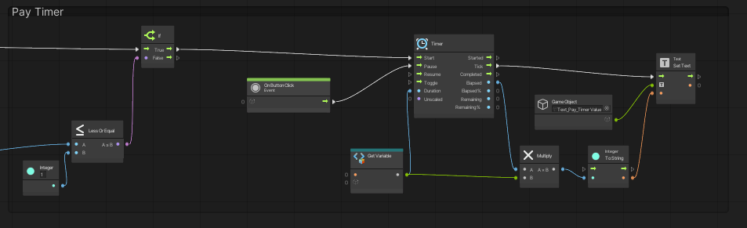
https://gyazo.com/d4495237831860fac5bc5ffd0d74c553
- Stand: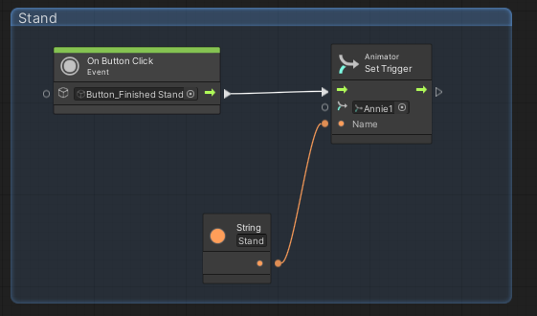
https://gyazo.com/de26c882e4f55b50564c36700a81245b
- Walk Look at: 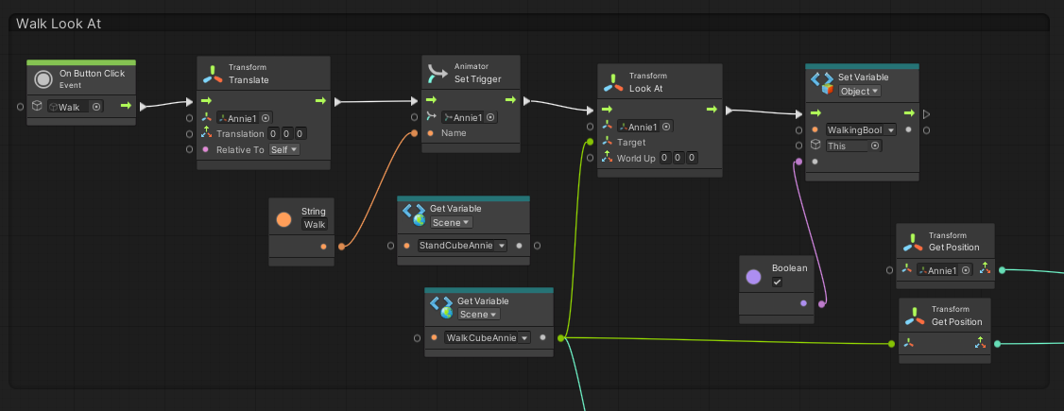
https://gyazo.com/fd6221f493fe86f4d1b34de351815891
- Walk Towards:
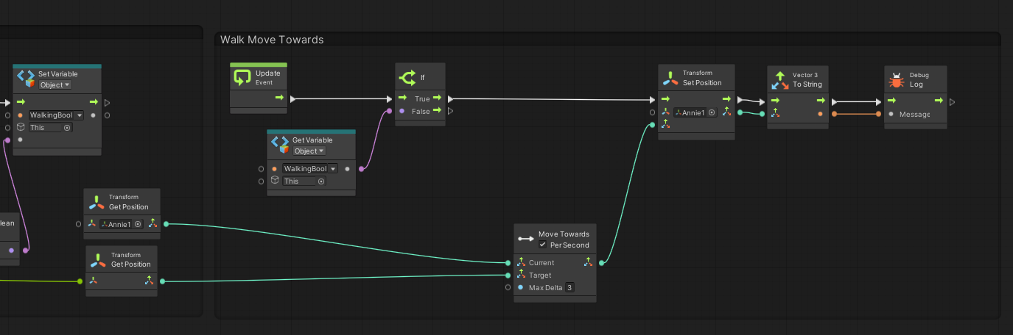
https://gyazo.com/a39f192adc8dae1d0f290c9f19d81d6b
- This should prove the pivots and movement sound, next step is to make movement more subtle by doing a quaternion lerp on the Look At, and to add elements such as a burger parented to the hand.

